**DATASETS**

|  |  |
| --- | --- |
| Date | 26 June 2025 |
| Team ID | LTVIP2025TMID30678 |
| Project Name | To Supply Leftover Food To Poor |
| College Name | Aditya collage of Engineering and Technology |

While the document does not include actual datasets (like CSV or Excel), it specifies

the fields used to store data.

**USER PROFILES DETAILS:**

**ALL USERS:**

"User details can be viewed in the User Session. Click on 'Setup' to access user information."

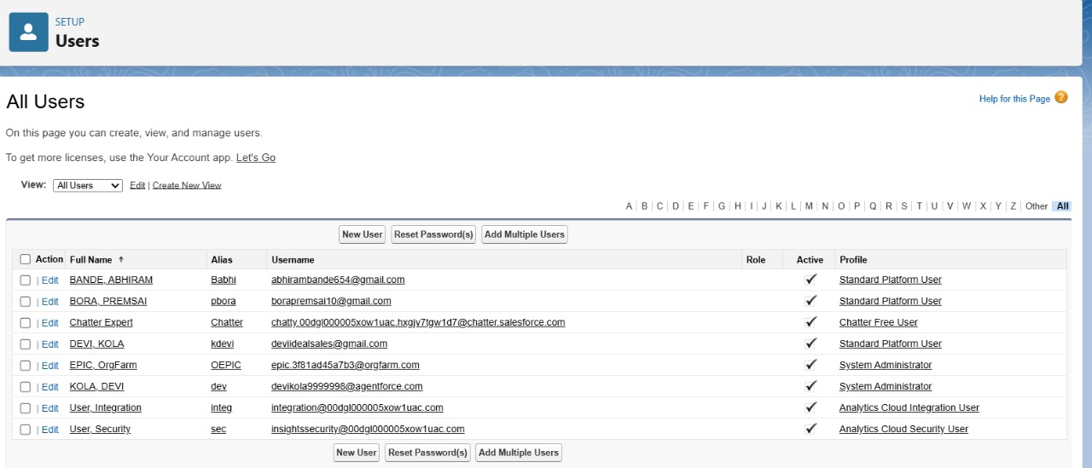

**USER 1:**

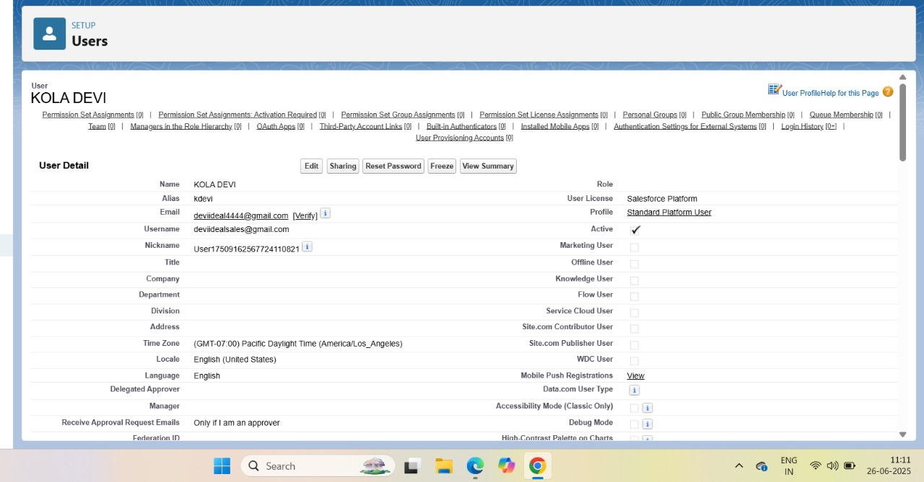

**USER 2:**

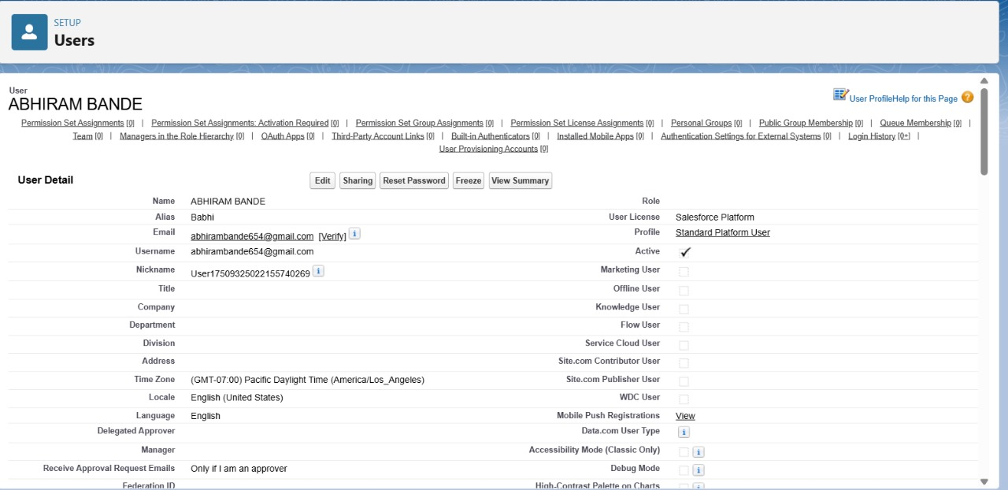

**USER 3:**

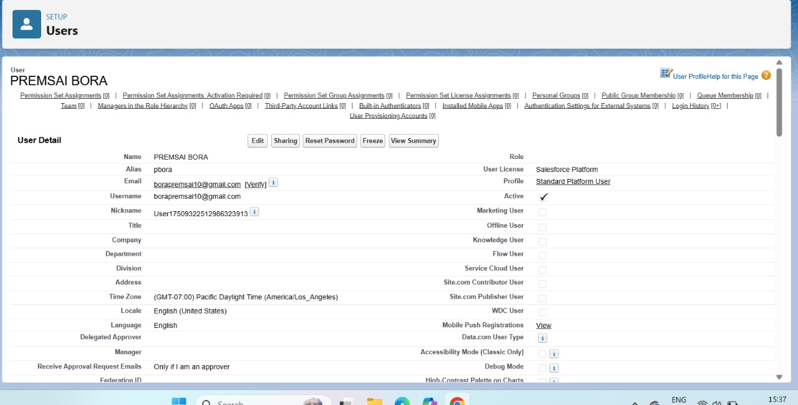

**NGO PROFILE DETAILS:**

